Internationalization (I18n)

Form I18n:
- Open the form.
- Activate the Navigator window.
- Right-click the form in this window, select Automatic Internationalization, click Design Locale.

Suppose that you want to create the form Form1 and I18n to it. You should follow the following steps:

1. Create the form, add some components to it, e.g. The form may look like below:

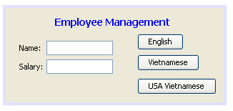

2. Open the Navigator window: (This step requires the form is already opened for editing) Click the item "Window" in the menu bar and select "Navigator" to open the Navigator window:
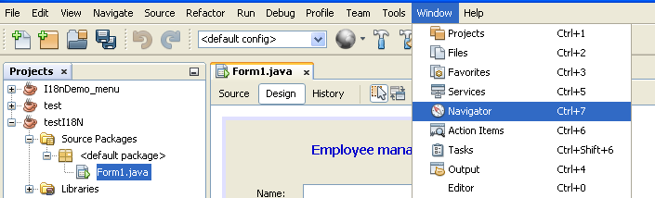

You can see the screen as below:
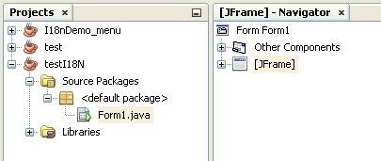
If you do not see the screen like this, you should click on the form Form1.

3. Create (defaullt) Properties Bundle file: Select the row Properties Bundle file
Right-click on the root node in the Navigator Window (Form:Form1), select Properties and in the Properties window, select the checkbox in the Automatic Internationalization property. Then the bundle file named Bundle.properties is automatically created with the content like below:

# To change this license header, choose License Headers in Project Properties.
# To change this template file, choose Tools | Templates
# and open the template in the editor.

Form1.lblTitle.text=Employee Management
Form1.lblName.text=Name:
Form1.lblSalary.text=Salary:
Form1.btnEN.text=English
Form1.btnVN.text=Vietnamese
Form1.btnVN_USA.text=USA Vietnamese

The Bundle.properties file contains the texts displayed at the form design. You can use this file to display the form with appearance at design by the following statements:
Locale loca;
ResourceBundle bund;
loca = new Locale("","");
bund = ResourceBundle.getBundle("Bundle", loca); // Bundle file name: Bundle.properties
lblTitle.setText(bund.getString("Form1.lblTitle.text"));
lblName.setText(bund.getString("Form1.lblName.text"));
lblSalary.setText(bund.getString("Form1.lblSalary.text"));
btnEN.setText(bund.getString("Form1.lblEN.text"));
btnVN.setText(bund.getString("Form1.lblVN.text"));
btnVN_USA.setText(bund.getString("Form1.btnVN_USA.text"));

3. Create bundle file for other languages:
Select the Design Locale row and click the icon 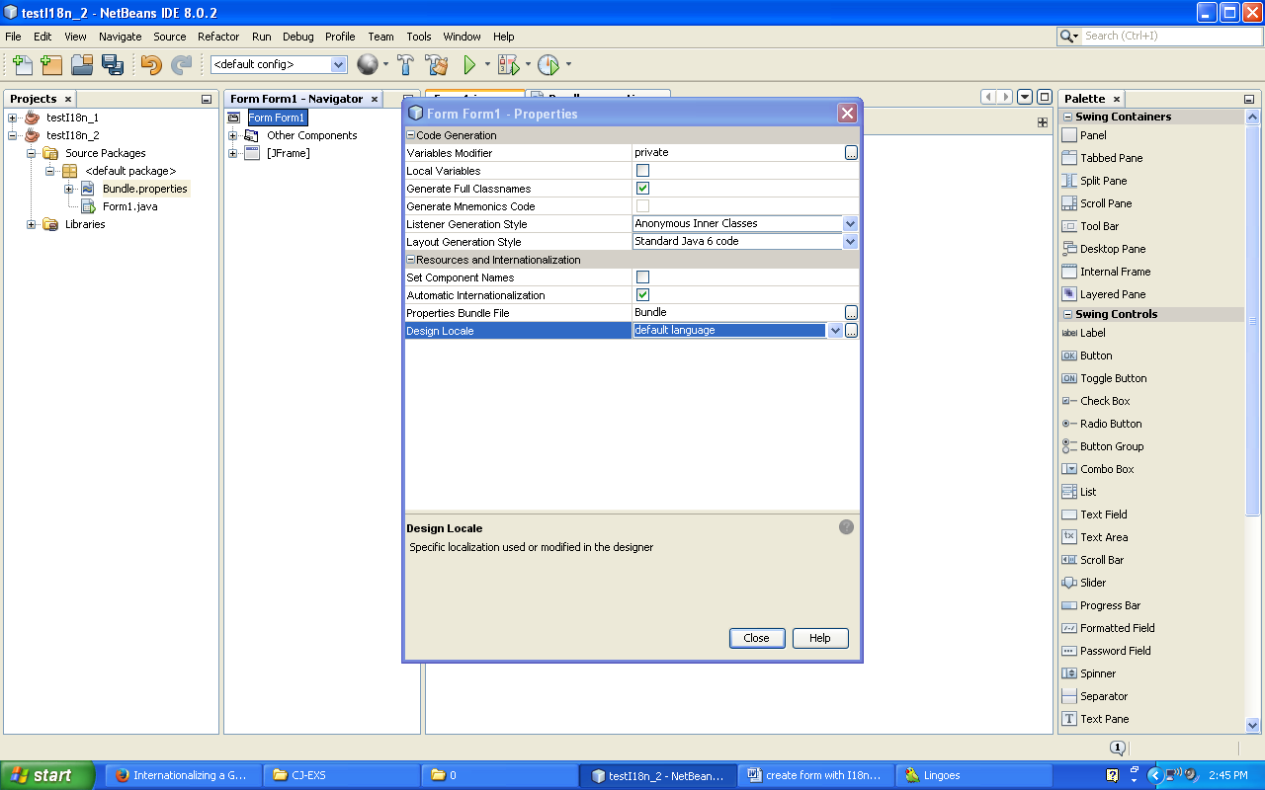
Suppose you select Language Code: vi (Vietnamese) and Country Code: VN (Vietname
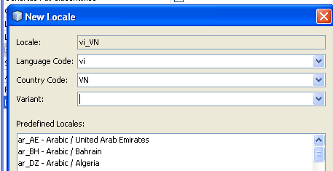
then click Ok and Close. The file named Bundle_vi_VN.properties is created. Open this file, you can see that it is still empty. You can copy the content of the default Bundle file to this file and edit as below:

Form1.lblTitle.text=Quản lý nhân viên
Form1.lblName.text=Họ tên:
Form1.lblSalary.text=Lương:
Form1.btnEN.text=Tiếng Anh
Form1.btnVN.text=Tiếng Việt
Form1.btnVN_USA.text=Tiếng Việt USA

By the same way, you can create the the bundle file named Bundle_vi_US.properties with the content below:

Form1.lblTitle.text=Quan ly nhan vien
Form1.lblName.text=Ho ten:
Form1.lblSalary.text=Luong:
Form1.btnEN.text=Tieng Anh
Form1.btnVN.text=Tieng Viet
Form1.btnVN_USA.text=Tieng Viet USA

4. Write functions and statements to use bundle files:
In the Form1.java, you can write the following functions:
Declare 2 class variables:
Locale loca;
ResourceBundle bund;

void setLang() {
lblTitle.setText(bund.getString("Form1.lblTitle.text"));
lblName.setText(bund.getString("Form1.lblName.text"));
lblSalary.setText(bund.getString("Form1.lblSalary.text"));
btnEN.setText(bund.getString("Form1.lblEN.text"));
btnVN.setText(bund.getString("Form1.lblVN.text"));
btnVN_USA.setText(bund.getString("Form1.btnVN_USA.text"));
}

void setEN() {
loca = new Locale("",""); // Bundle file name: Bundle.properties
bund = ResourceBundle.getBundle("Bundle", loca);
setLang();
}

void setVN() {
loca = new Locale("vi","VN"); // Bundle file name: Bundle_vi_VN.properties
bund = ResourceBundle.getBundle("Bundle", loca);
setLang();
}

void setVN_USA() {
loca = new Locale("vi","US"); // Bundle file name: Bundle_vi_US.properties
bund = ResourceBundle.getBundle("Bundle", loca);
setLang();
}
The statements for buttons:
English: setEN();
Vietnamese: setVN();
USA Vietnamese: setVN_USA();
===============================================================================
Summary:
String lang;
String country;
Locale loca;
ResourceBundle bund;

// Default case (English)
lang = new String("");
country = new String("");
loca = new Locale(lang, country);
bund = ResourceBundle.getBundle("Bundle",loca); // Bundle file name: Bundle.properties

Default case (English):
String xName, xAddress, xJob;
xName = bund.getString("name");
xAddress = bund.getString("address");
xJob = bund.getString("job");

// American English: en_US
lang = new String("en");
country = new String("US");
loca = new Locale(lang, country);
bund = ResourceBundle.getBundle("Bundle",loca); // Bundle file name: Bundle_en_US.properties

